TUTORIAL TO OUR GAME PROJECT

Install the Pygame package.

# 

1. File - Settings.
2. Double click on your project name.
3. Select Project Interpreter.
4. Click on green + button on the right side of the window.
5. Type **Pygame** in search window.
6. Click **Install** package.

Than **init()** initialize all imported **pygame** modules.

After we create the window to our game:

size = [SIZE_OF_BLOCK * COUNT_OF_BLOCKS + 2 * SIZE_OF_BLOCK + MARGIN * COUNT_OF_BLOCKS,  
 SIZE_OF_BLOCK * COUNT_OF_BLOCKS + 2 * SIZE_OF_BLOCK + MARGIN * COUNT_OF_BLOCKS + INTENT_MARGIN]

With **pygame.display.set_mode** we initialize the window for display.

pygame.display.set_caption('Snake')

So that the window does not close, we will make an endless loop:

while True:  
  
 for event in pygame.event.get():  
 if event.type == pygame.QUIT:  
 print('Exit')  
 pygame.quit()  
 sys.exit()

So that the window does not close, we will make an endless loop:

while True:  
  
 for event in pygame.event.get():  
 if event.type == pygame.QUIT:  
 print('Exit')  
 pygame.quit()  
 sys.exit()

After we create a playing field with the help of boxes:

SIZE_OF_BLOCK = 20  
BACK_COLOR = (150, 150, 150)  
MAIN_COLOR = (255, 255, 255)  
WHITE = (255, 255, 255)  
BLUE = (204, 255, 204)  
BLACK = (50, 50, 50)  
RED = (200, 50, 50)  
SNAKE_COLOR = (50, 150, 50)  
MARGIN = 1  
INTENT_MARGIN = 70  
COUNT_OF_BLOCKS = 20

Result:

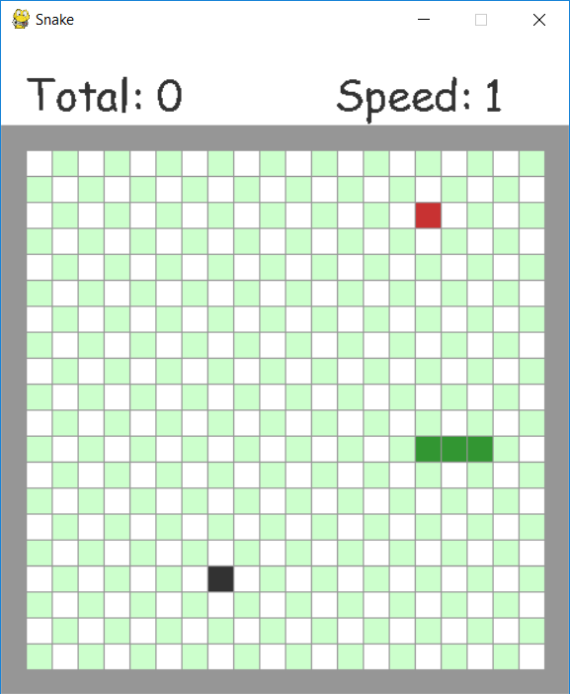

And do not forget transfer it to loop:

screen.fill(BACK_COLOR)  
pygame.draw.rect(screen, MAIN_COLOR, [0, 0, size[0], INTENT_MARGIN])

So that there are enough columns for the window, we create a **for loop** and go through the columns:

for raw in range(COUNT_OF_BLOCKS):  
 for column in range(COUNT_OF_BLOCKS):  
 if (raw + column) % 2 == 0:  
 color = WHITE  
 else:  
 color = BLUE

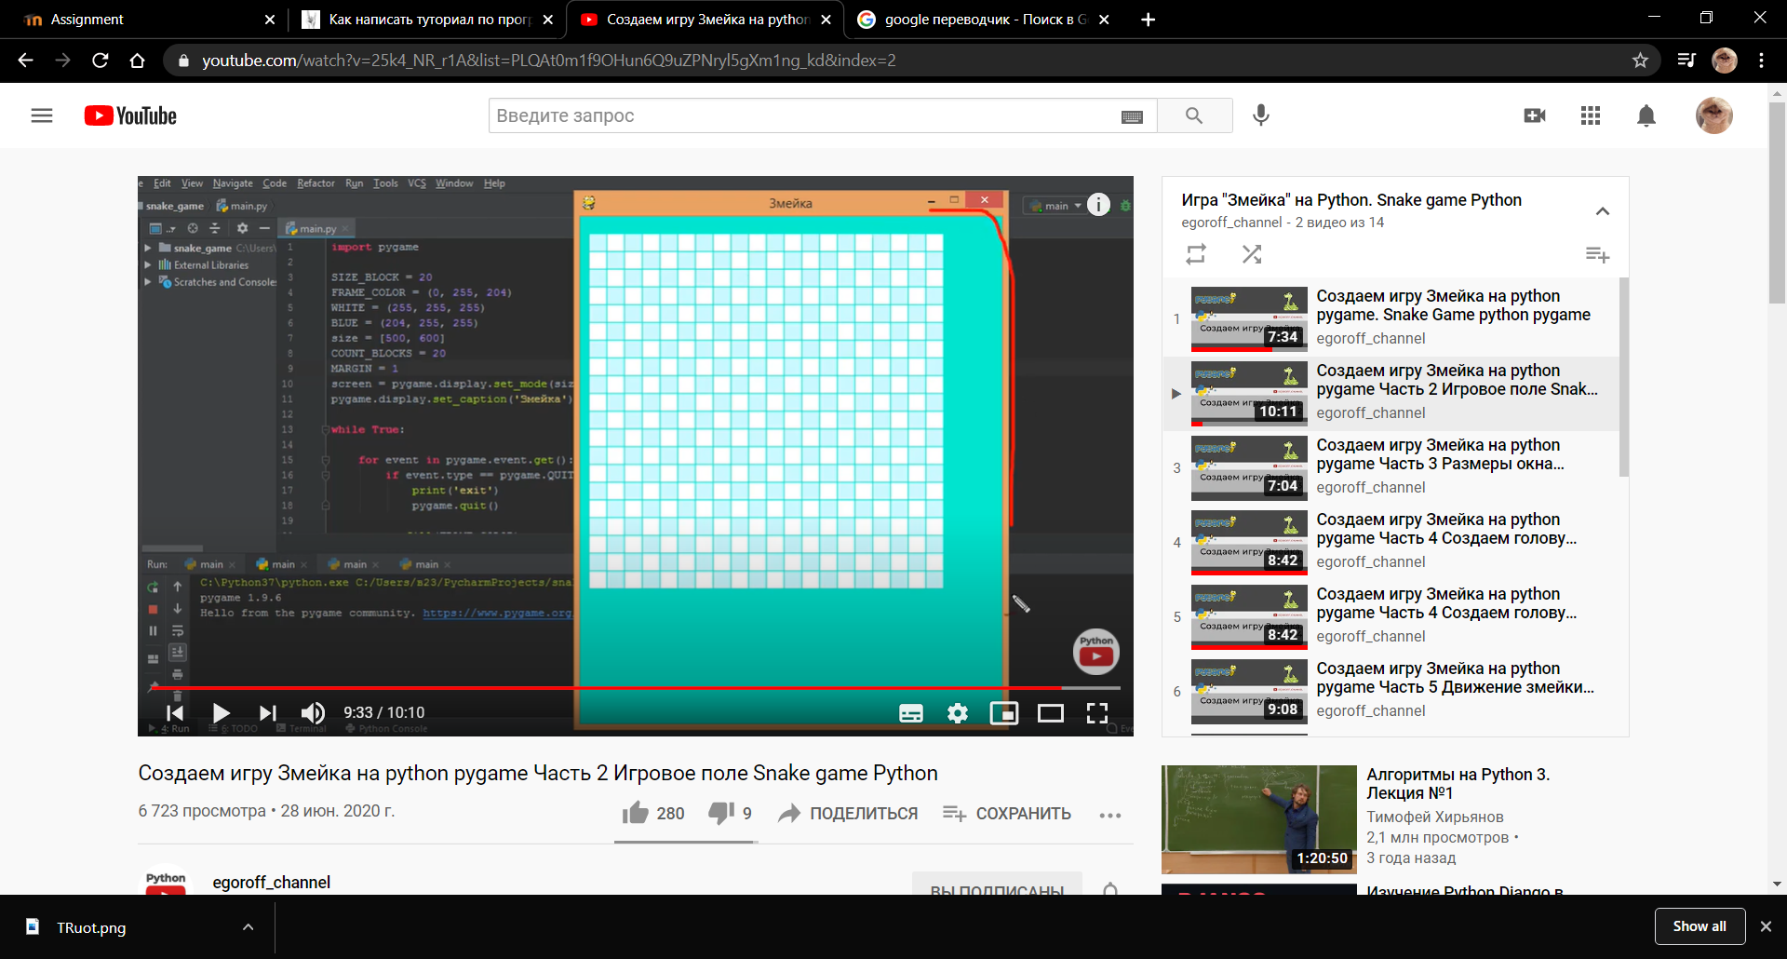

**Creating a snake**

snake_blocks = [SnakeBlocks(13, 12), SnakeBlocks(12, 12), SnakeBlocks(11, 12)]  
apple = random_empty_block()  
stones = random_empty_block()  
d_raw = 0  
d_col = 1  
total = 0  
speed = 1

Creating a class(OOP):

class SnakeBlocks:  
 def __init__(self, x, y):  
 self.x = x  
 self.y = y

Now we should do   
must make the snake move, and if it touches its head, the game will end.

for raw in range(COUNT_OF_BLOCKS):  
 for column in range(COUNT_OF_BLOCKS):  
 if (raw + column) % 2 == 0:  
 color = WHITE  
 else:  
 color = BLUE  
  
 draw_blocks(color, column, raw)  
  
snake_head = snake_blocks[-1]  
if not snake_head.is_inside():  
 print('You have crashed')  
 break  
  
draw_blocks(BLACK, stones.x, stones.y)  
draw_blocks(RED, apple.x, apple.y)  
for block in snake_blocks:  
 draw_blocks(SNAKE_COLOR, block.x, block.y)  
  
if stones == snake_head:  
 print('You encountered a stone')  
 break  
  
if apple == snake_head:  
 total += 1  
 speed = total // 5 + 1  
 snake_blocks.append(apple)  
 apple = random_empty_block()

new_head = SnakeBlocks(snake_head.x + d_raw, snake_head.y + d_col)  
if new_head in snake_blocks:  
 print('You have crashed yourself')  
 break  
  
snake_blocks.append(new_head)  
snake_blocks.pop(0)

**Adding a ‘Total score’ and ‘Speed of Snake’:**

text_total = my_font.render(f"Total: {total}", False, BLACK)  
text_speed = my_font.render(f"Speed: {speed}", False, BLACK)  
screen.blit(text_total, (SIZE_OF_BLOCK, SIZE_OF_BLOCK))  
screen.blit(text_speed, (SIZE_OF_BLOCK + 250, SIZE_OF_BLOCK))

**Food for Snake:**

if apple == snake_head:  
 total += 1  
 speed = total // 5 + 1  
 snake_blocks.append(apple)  
 apple = random_empty_block()

Use **pygame-menu** library for making menu. As I showed you at the beginning you have to install this package. Ans lets do the menu:

menu = pygame_menu.Menu(220, 300, 'Welcome',  
 theme=pygame_menu.themes.THEME_GREEN)  
  
menu.add_text_input('Name: ', default='')  
menu.add_button('Play', start)  
menu.add_button("Exit", pygame_menu.events.EXIT)

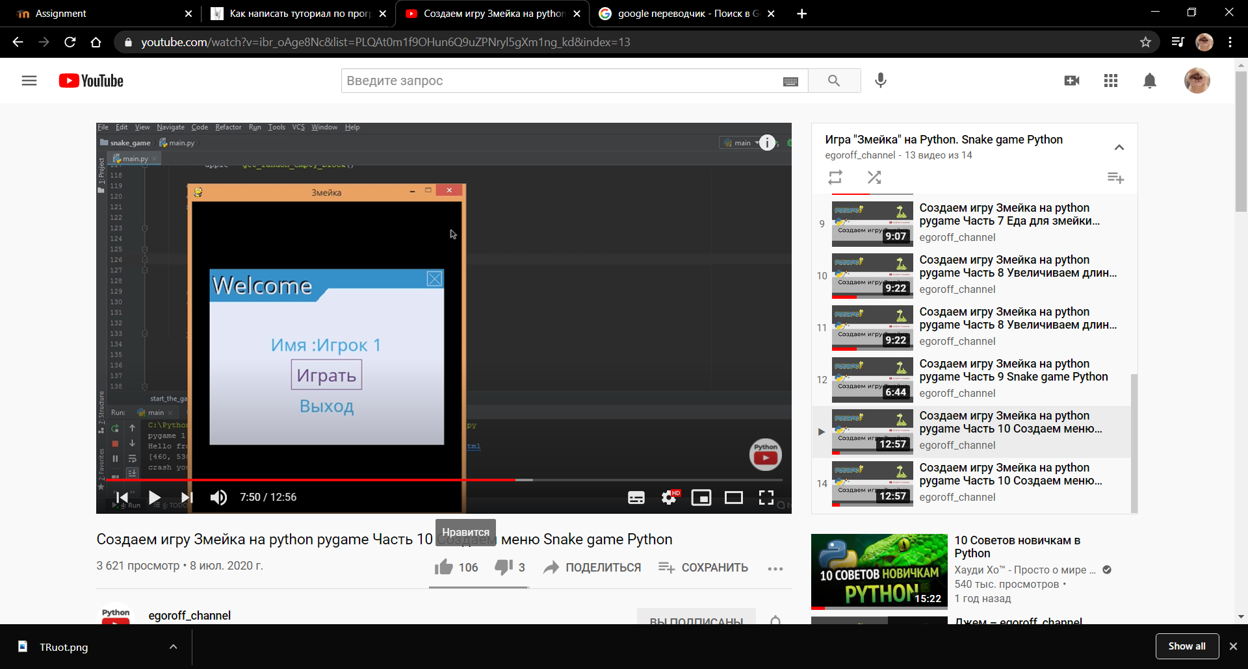

**To pause the game:**

def pause():  
 paused = True  
 global d_col  
 global d_raw  
 while paused:  
 for event in pygame.event.get():  
 if event.type == pygame.QUIT:  
 print('Exit')  
 pygame.quit()  
 sys.exit()  
  
 elif event.type == pygame.KEYDOWN:  
 if event.key == pygame.K_q:  
 pygame.quit()  
 quit()  
 elif event.key == pygame.K_RETURN:  
 paused = False

So, ESC is to pause, ENTER to unpause.

And at the end we add music and background picture for menu window:

1.We download the music from freesound.com,copying it and insert it in project

2.Install the music library **from pygame import mixer**

mixer.music.load("515946__mrthenoronha__detective-game-theme-loop.wav")  
mixer.music.play(-1)

With picture we also do like that and writing:

back_image = pygame.image.load("picture.jpg")

do not forget transfer it in loop.

